**Experiment 8: Sampling Theorem**

In this experiment, we will verify the Sampling Theorem which states that a sampled signal can be reconstructed exactly if the sampling rate is at least twice the maximum frequency component in it. It is expected that the student will write a “readable” MATLAB code in a file and execute for the following problems.

1. (i) Generate a cosine signal of frequency 0.25Hz and amplitude 5V.

(ii) plot the cosine signal by sampling the signal using a sampling frequency of

(a) fs1=1.6*fm (b) fs2=2*fm,and (c) fs3= 8*fm.

(iii) Use subplots to show the original signal, the signal when sampled at fs1, fs2 and fs3.

Ans:

fs = 5e3;

f = 0.25;

nCyl=5;

t=0:1/fs:nCyl*1/f;

x = 5*cos(2*pi*f*t);

fs1 = 1.6*f;

t1 = 0:1/fs1:nCyl*1/f;

x1 = 5*cos(2*pi*f*t1);

fs2 = 2*f;

t2=0:1/fs2:nCyl*1/f;

x2 = 5*cos(2*pi*f*t2);

fs3 = 8*f;

t3 = 0:1/fs3:nCyl*1/f;

x3 = 5*cos(2*pi*f*t3);

subplot(411)

plot(t, x);

xlabel("x"), ylabel("time")

title("Original plot")

subplot(412);

plot(t,x);

hold on;

stem(t1,x1);

xlabel("x1"), ylabel("time")

title("Reconstruction for fs = 1.6fm")

subplot(413);

plot(t,x);

hold on;

stem(t2,x2)

xlabel("x2"), ylabel("time")

title("Reconstruction for fs = 2fm")

subplot(414);

plot(t,x);

hold on;

stem(t3,x3)

xlabel("x3"), ylabel("time")

title("Reconstruction for fs = 8fm")

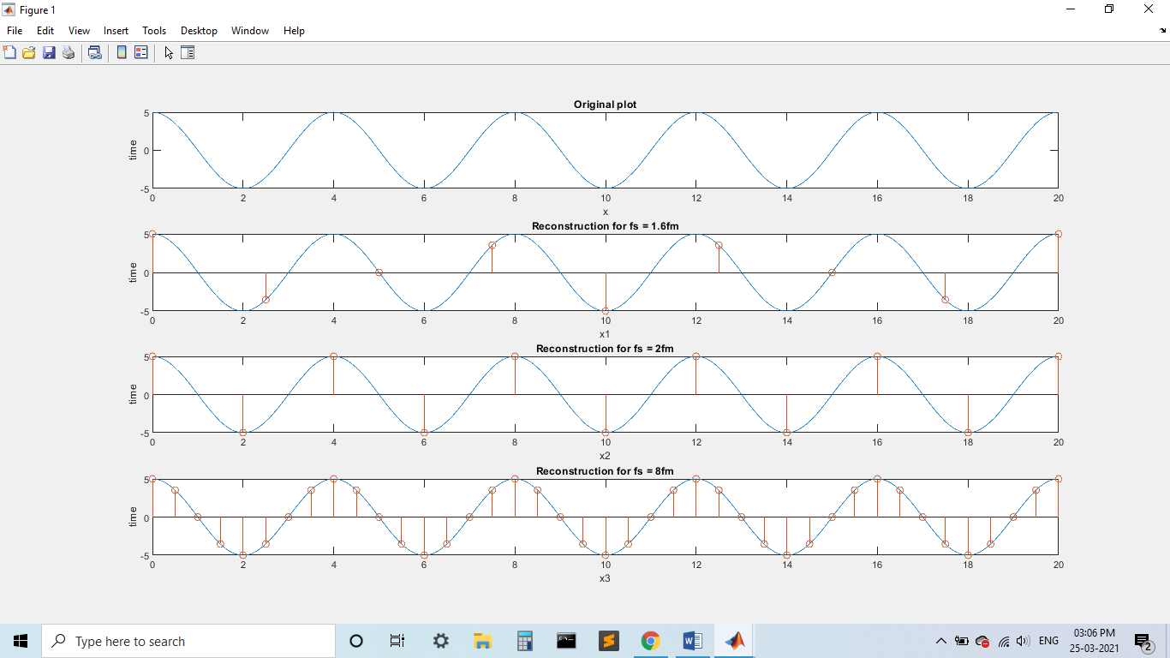

1. (i) Plot the given signal x(t)=1cos(31.4t)+2cos(188.5t)+0.5cos(43.98t)

(ii) For the given above signal, identify the sampling frequency (fs) and

(iii) plot by assuming a value for Fs < 2*fmax, Fs > 2*fmax

%the sampling rate will that for the highest frequency i.e 30Hz here.

fs = 5e3;

f = 30;

nCyl=5;

t=0:1/fs:nCyl*1/f;

x = cos(31.4*t)+2*cos(188.5*t)+0.5*cos(43.98*t);

fs1 = 1.6*f;

t1 = 0:1/fs1:nCyl*1/f;

x1 = cos(31.4*t1)+2*cos(188.5*t1)+0.5*cos(43.98*t1);

fs2 = 2*f;

t2=0:1/fs2:nCyl*1/f;

x2 = cos(31.4*t2)+2*cos(188.5*t2)+0.5*cos(43.98*t2);

fs3 = 8*f;

t3 = 0:1/fs3:nCyl*1/f;

x3 = cos(31.4*t3)+2*cos(188.5*t3)+0.5*cos(43.98*t3);

subplot(411)

plot(t, x);

xlabel("x"), ylabel("time")

title("Original plot")

subplot(412);

plot(t,x);

hold on;

stem(t1,x1);

xlabel("x1"), ylabel("time")

title("Recontsruction for fs < 2*fm")

subplot(413);

plot(t,x);

hold on;

stem(t2,x2)

xlabel("x2"), ylabel("time")

title("Recontsruction for fs = 2*fm")

subplot(414);

plot(t,x);

hold on;

stem(t3,x3)

xlabel("x3"), ylabel("time")

title("Recontsruction for fs > 2*fm")

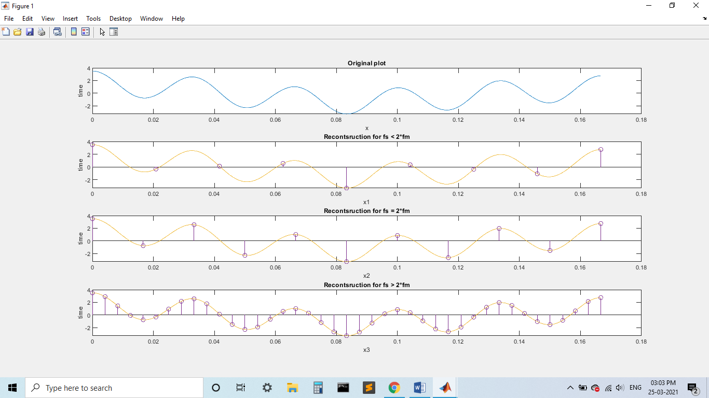

**Link to upload files**

**Tuesday Batch https://forms.gle/BWzgntNfm99eZ2tBA**

**Sunday of the week in which you perform this experiment mostly April 11th 5 PM**

**Thursday batch https://forms.gle/kc8VNerXjGLQMD529**

**Due on March 28th 5 PM**